# Defining the workflow

**Executive summary**

* We used an inward‑facing orbit at multiple heights with 70–80% overlap, then added ceiling/floor and corner shots.
* High overlap and convergent geometry delivered stable alignment with fewer non‑estimated cameras and fewer holes.
* Uniform walls needed reference markers; reflections and mixed lighting were controlled.
* Camera was run fully manual (f/8–f/11, ISO 100–200, 1/60s+, WB fixed, RAW).
* For a 2×1 m room, ~120–140 photos covered the scene cleanly.

**Why the inward‑facing orbit worked**

* High overlap and multi‑angle coverage improved feature matching and reduced non‑estimated cameras.
* Convergent geometry (camera aimed slightly inward) increased parallax on walls/corners and improved vertical reconstruction.
* Systematic path at consistent heights and lens settings produced uniform, alignable data.
* Full perimeter passes plus ceiling/floor minimized blind spots and mesh holes.

**Marker points (what we used and why)**

* Purpose: add distinct, high‑contrast features so alignment stays stable on uniform surfaces (white walls, smooth floors).
* Type: simple bold black “X” or dot on A4; optionally coded circles if using software that supports auto‑target detection.
* Placement principles:
* Walls: 3–4 per wall, spread horizontally and vertically; eye/mid/near‑floor; avoid perfect grids.
* Corners: offset 20–30 cm from edges so they’re visible from multiple angles.
* Floor/near ceiling: a few for 3D reference.
* Glass: avoid sticking to glass; place near it on floor/ceiling or use matte tape if necessary.
* No duplicates: rotate/label to avoid identical targets.

**Camera and capture settings (Canon EOS 650D)**

* Mode: Manual.
* Aperture: f/8–f/11 for depth of field.
* Shutter: 1/60s or faster (avoid blur).
* ISO: 100–200 (keep noise low).
* White balance: fixed (not Auto).
* Focus: manual (prevent focus shifts).
* Format: RAW (CR2), convert later for processing; JPEG acceptable for quick tests.
* Stabilization: off when on tripod.

**Shooting plan used**

* Three orbits around the room, camera slightly inward:
* Low: ~0.5–0.7 m
* Mid: ~1.3 m
* High: ~1.8 m
* Take a shot every 20–30 cm; maintain ~70–80% overlap.
* Ceiling and floor:
* From centre, 4–6 upward shots toward corners; repeat angled down for floor; include some wall in frame for context.
* Corner reinforcement:
* 2–3 angled shots per corner from ~1 m, with small variations in tilt/distance.

**ISO 100**

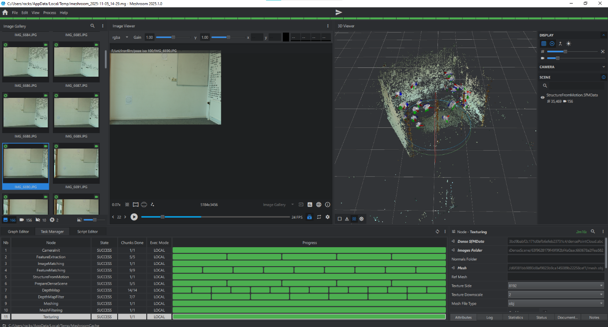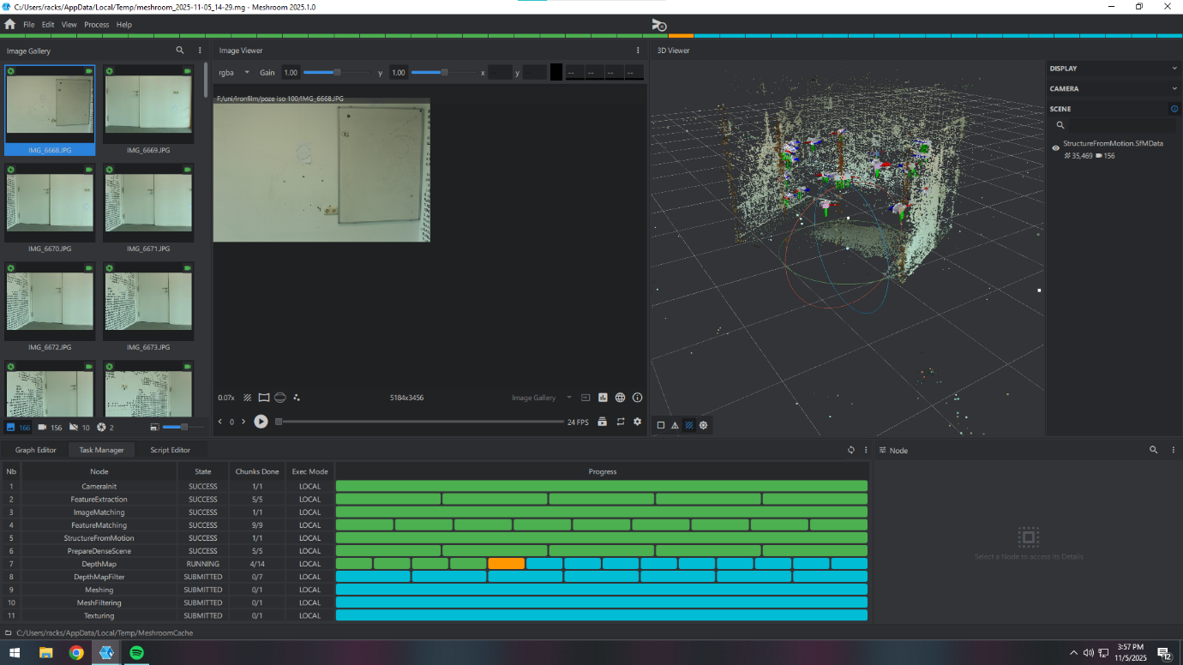

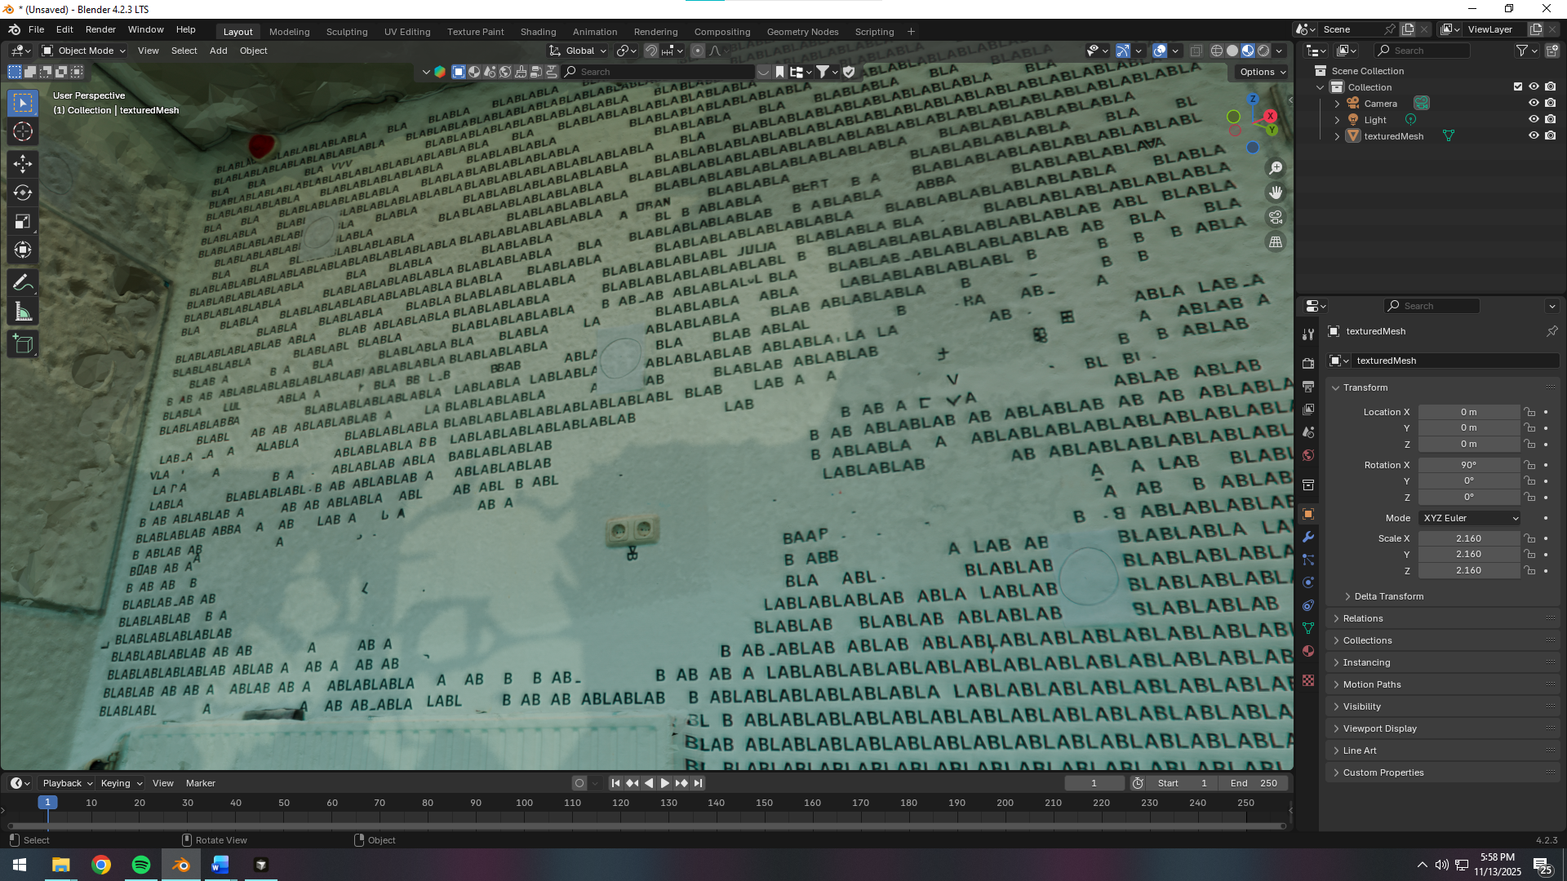 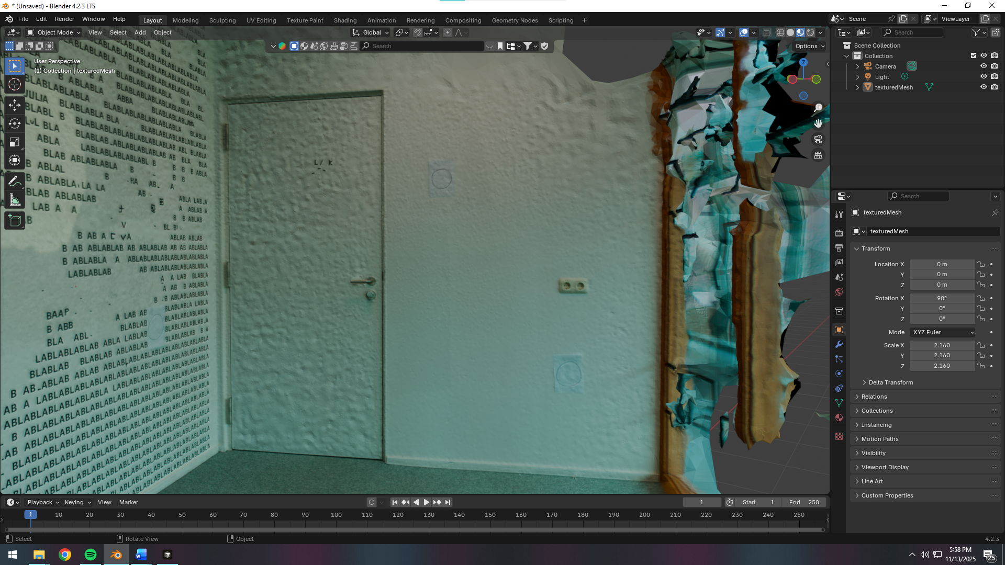

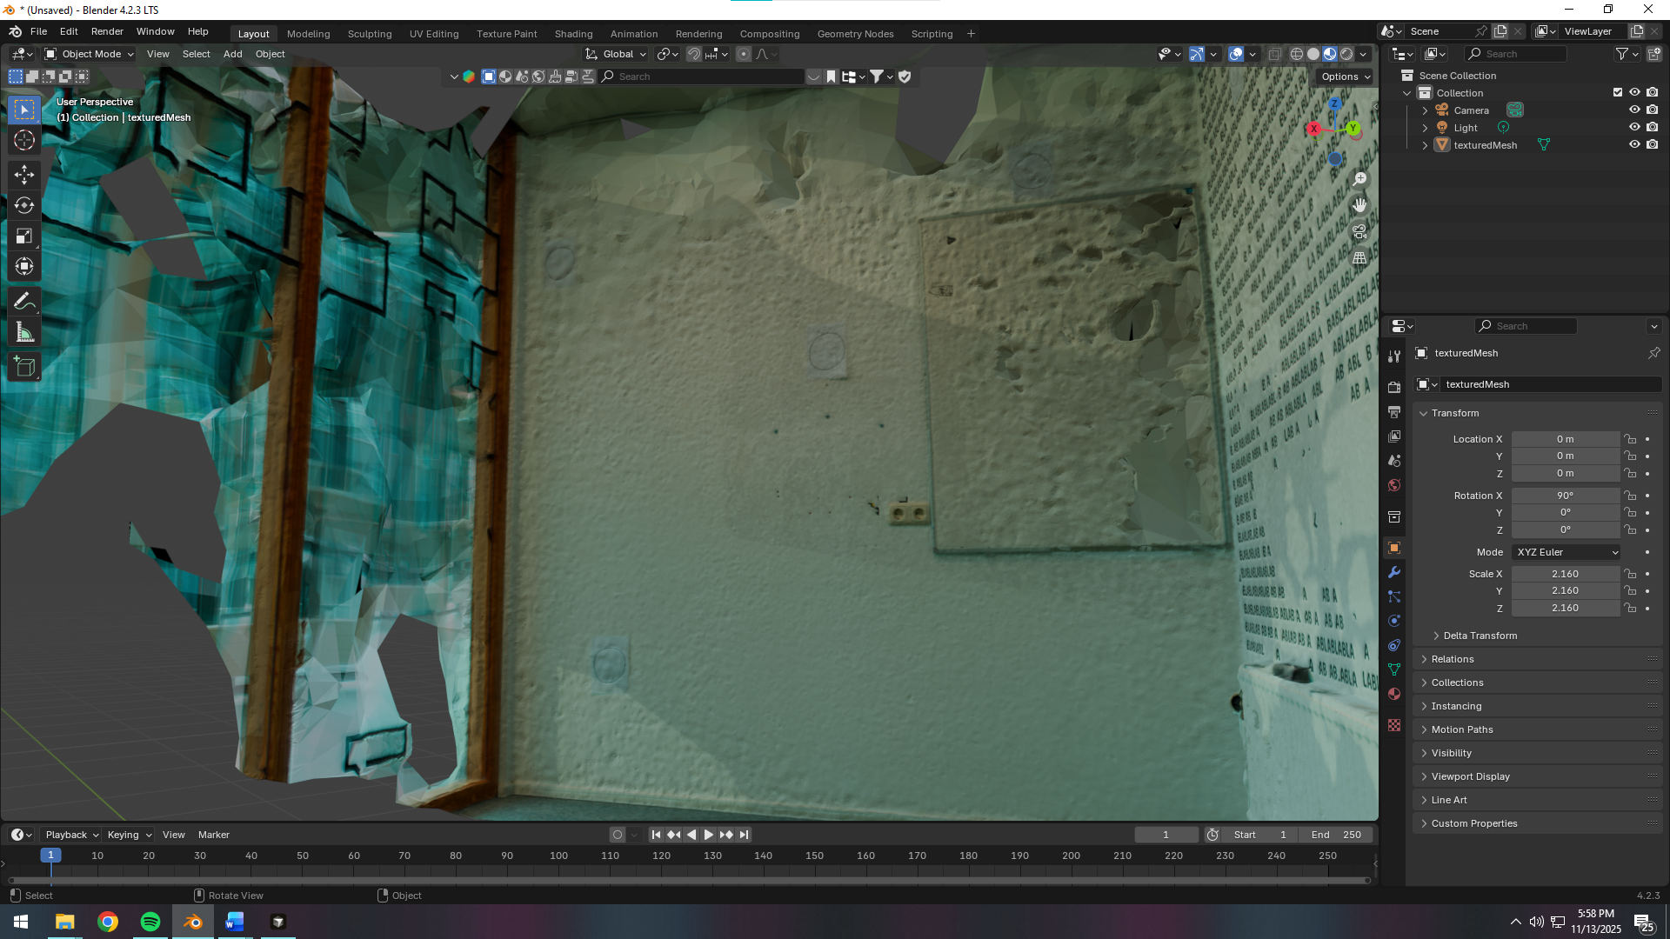

>>>>>>>>>>>>>>>>>>>>>>>>>>>>>>>>>>>>>>>>>>>>>>>>>>>>>>>>>>>>>>>>>>>>>>

**ISO 200**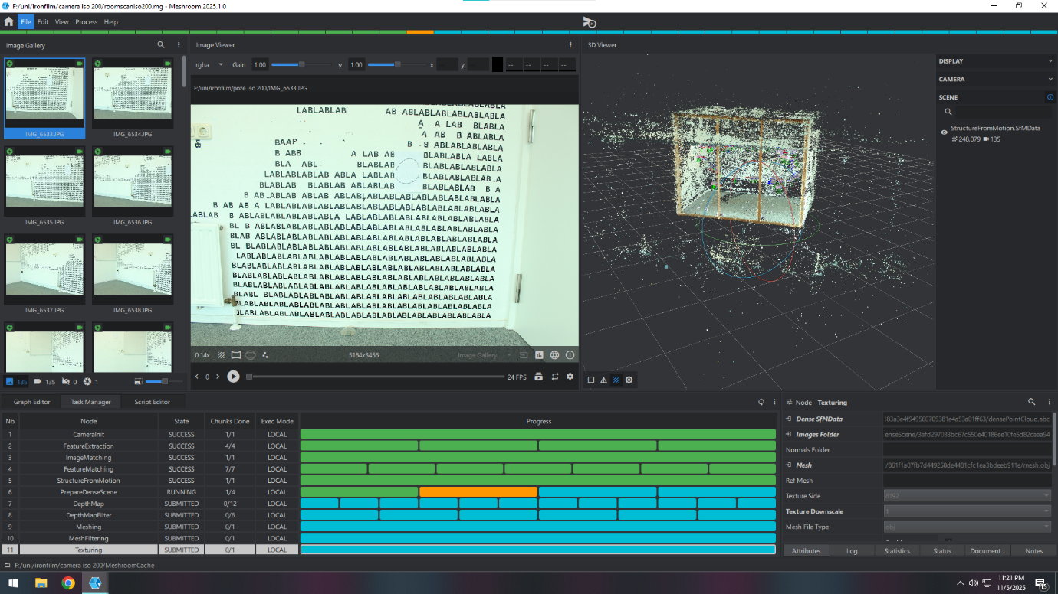

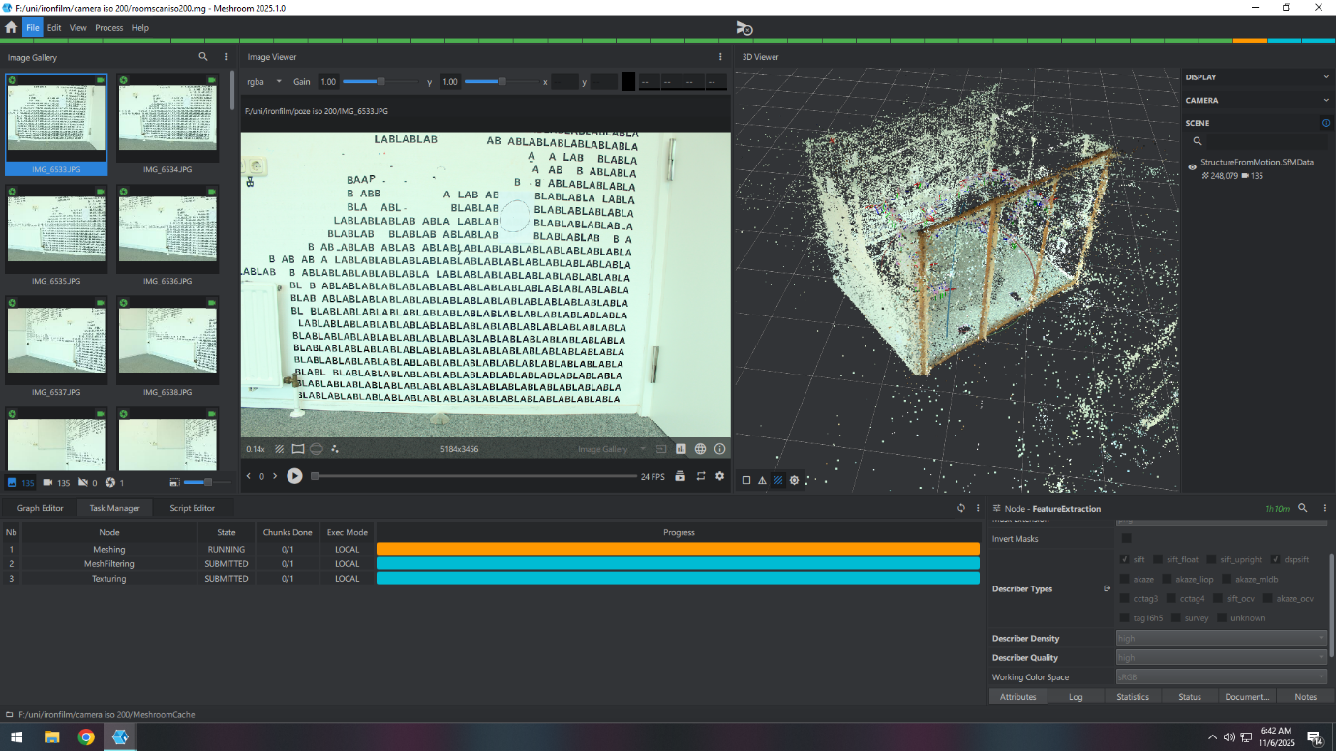

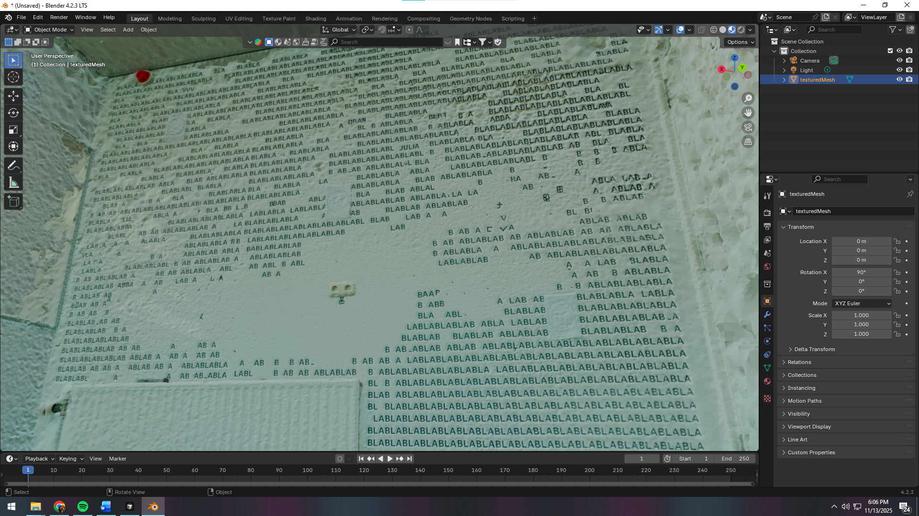

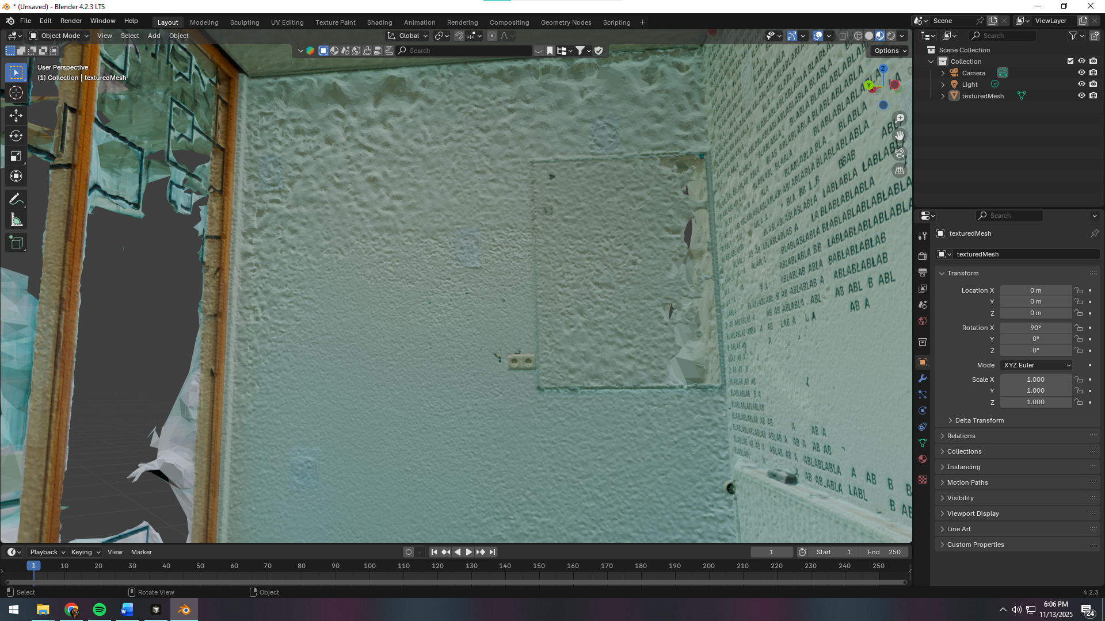

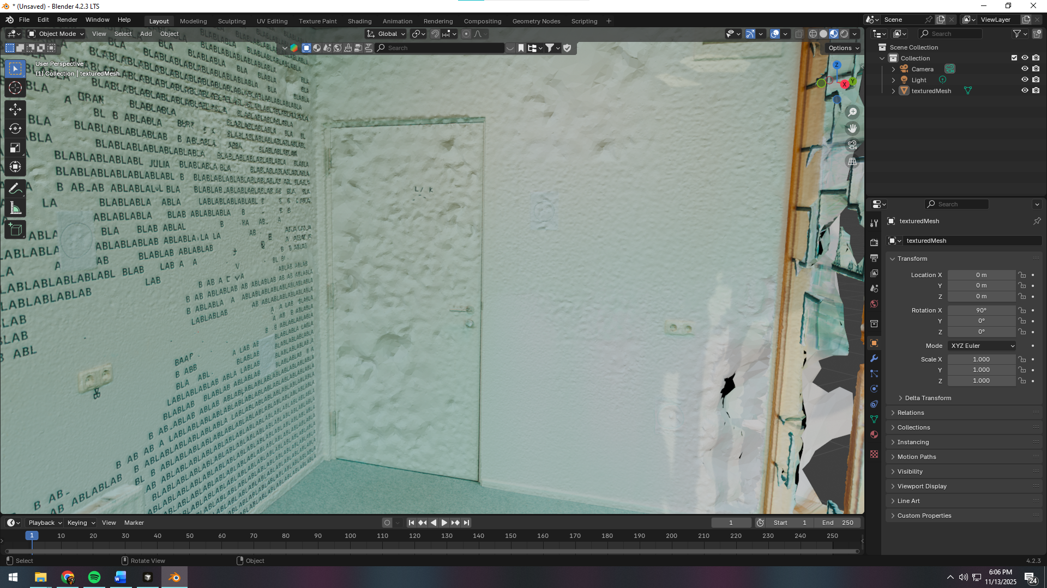

**ISO 100 vs ISO 200 — comparison (completed)**

**Outcome**

* **ISO 200 produced slightly brighter, higher‑contrast images, which increased SIFT feature detections and improved alignment in darker corners.**
* **ISO 100 was cleaner (lower noise) but too flat in some areas; corners underexposed → fewer matches.**

**Processing choices that helped**

* **SIFT only: more stable, cleaner matches for a structured interior.**
* **DepthMap Downscale = 1: maximum geometric detail (longer runtime, acceptable for finals).**
* **Max Neighbour Cameras = 14: smoother, more continuous surfaces indoors.**
* **Texture 8K (8192): crisp textures given high‑res inputs.**

**What worked well**

* **Consistent lighting and exposure across the set.**
* **High overlap with systematic paths.**
* **Printed A4 markers materially improved correspondences on uniform walls.**

**Further gains (next runs)**

* **Add lamps/reflectors to lift corners and reduce shadow variance.**
* **If ceiling/floor are sparse, add a dedicated pass to reach ~140–200 photos.**
* **Mitigate reflections (cover glass, block window views).**
* **Validate poses in Meshroom (show cameras; delete obvious misalignments) before meshing.**
* **In Blender: Decimate if heavy; smooth shading and normal‑map bake for presentation.**